
SOCIAL WATCH

An international network of citizens’ coalitions committed to poverty eradication and social, economic and gender justice

The use of indicators in assessing social development

SOCIAL SCIENCES RESEARCH TEAM

January 2007

socwatch@socialwatch.org
www.socialwatch.org

Social indicators have become indispensable tools for discussion and policy-making in diverse fields and arenas both within countries and at an international level. However, they are still shrouded in an aura of technicality that makes them “inaccessible” for most people. Although their construction does involve technical elements, indicators can and should be accessible for appropriation and criticism by the community. This constitutes part of citizenship construction by enabling dialogue and monitoring based on transparent and responsible information management on the part of both citizens and governments.

Social Watch is an international network of citizens’ organizations struggling to eradicate poverty and the causes of poverty, to ensure an equitable distribution of wealth and the realization of human rights. We are committed to social, economic and gender justice, and we emphasize the right of all people not to be poor. Social Watch will achieve its objectives through a comprehensive strategy of advocacy, awareness-building, monitoring, organizational development and networking. Social Watch promotes people-centred sustainable development.

Using objective indicators Social Watch has always geared its efforts to measuring governments’ achievement of targets set by themselves at different international forums. Consequently Social Watch Reports are a tool that people the world over can use to make their governments, the UN system and international organizations accountable.
Social Watch annual reports have included a follow-up on the situation of countries in relation to development goals that governments committed themselves to during the World Summit for Social Development in Copenhagen and at the Fourth World Conference on Women in Beijing, as well as the most recent goals of the Millennium Declaration for 2015.

This paper’s objective is to disseminate some basic concepts relating to the definition, nature, methodology and use of social indicators and in particular to present Social Watch’s work based on them. One specific objective is that it will contribute to the various dissemination, training and discussion activities in workshops of Social Watch and other institutions that want to use it.
It is a paper under construction and as such is open to suggestions, criticisms or additions that users may want to make in order to improve and enrich its contents.
It is also an advance of an Occasional Paper that Social Watch will publish in mid-2007, deepening and widening the contents briefly presented here.
We will be grateful if you can read, use and review it and we invite you to send us pertinent comments.

Table of Contents

PART ONE: Basic concepts of social indicators
1. What is a social indicator and what is it for?
2. Construction and selection of indicators
3. Social indicators systems

PART TWO: The work of Social Watch
4. Development indicators for international monitoring
5. Present situation and progress in social development dimensions
6. A human rights perspective
7. Basic Capabilities Index (BCI)
8. Gender Equity Index (GEI)
PART ONE:
Basic concepts of social indicators

1. WHAT IS A SOCIAL INDICATOR AND WHAT IS IT FOR?

Some definitions:

- A social indicator is a tool to measure or operationalize an abstract social concept (of theoretical or programmatic interest).

- It is a construction based on a methodology that yields information about an aspect of a real situation or about changes that have occurred in that situation.

- The indicators translate various important specific dynamic dimensions of social reality into tangible figures.

- Social indicators are conventionally adopted and their use becomes generalised and legitimised through user perception of their utility (in social, economic and political fields).

- From the academic perspective an indicator is the link between explanatory models of social theories and empirical evidence.

- From the programmatic perspective an indicator is an operational tool for monitoring social reality so as to formulate or reformulate policies.

- Under this perspective, it provides measurements for evaluation in relation to a norm or desirable situation (goal).

- In choosing to use an indicator not only the scientific rigour applied in its construction is important but also the credibility and reliability that it has in the eyes of users in regard to its measurement capacity for the situations and processes being analysed.

What is their utility?

- They are tools that provide information on a situation or process of interest
- Measure progress or regression
- Facilitate an estimation of phenomena magnitude and incidence
- Assist in policy decision-making, the setting of goals, initiative result evaluation and the monitoring of progress, regression or stagnation
- Facilitate independent monitoring of initiatives by all those involved in them
- Can function as an early warning system to prevent the development of critical situations
- Enable the identification of vulnerable groups or risk situations.
2. CONSTRUCTION AND SELECTION OF INDICATORS

  - Data becomes an indicator in response to a question about reality and such questions arise from a certain view of that reality.

From the problem to the indicator:

- Conceptually define the problem or area to be studied
- Define the dimensions and sub-dimensions of the analysis
- Identify pertinent variables in each dimension

Examples of concepts the dimensions and variables of which need to be defined:
- Social development
- Poverty
- Equity

The choice of indicators:

- The facts or activities chosen for studying variables provide data for the construction of indicators (measurable expressions of the variables)
- Identifying which indicators yield knowledge about the behaviour of variables is called operationalizing (it is necessary to choose which indicators most directly reflect the variable in question).
- There are many possible indicators to measure the same variable – the most suitable have to be found.
- Some are more reliable but measurement is difficult, and they must be superseded by others that are more accessible or easier to obtain.
- Some indicators do not measure the core aspect in question but some connected or collateral phenomenon.

The collection of data:

The information needed to construct the indicators can be collected directly (PRIMARY SOURCE) or come from a collection made by others (SECONDARY SOURCE). For the user, these two types of sources are different in regards to the control of the data compiling process (objectives and tools used for compiling).

 |  | PRIMARY | The collection process can be controlled | Ex: survey conducted by the user of the data
SOURCES
 |  | SECONDARY | The collection process cannot be controlled | Ex: Survey conducted by others, administrative records , etc.

In particular, statistics produced by public agencies are a very important secondary source of data that can be used for constructing indicators. When using these sources it has to be taken into account that even the most basic compilation of an administrative event is done with a purpose and its corresponding procedures.

Example: To compare the evolution of social development among countries, comparable public statistics are mainly used, frequently compiled out of international agencies’ data bases (UNESCO, WHO, etc.).
Criteria for constructing and selecting indicators

- Relevance: pertinence in a social or political agenda context

- Clarity: easily understood by the community

- Social legitimacy: accepted as an appropriate information element in stakeholders’ debate

- Validity: having an appropriate correspondence with the concept being measured

- Reliability: that technical procedures used in data collection and indicator construction generate consistent measurements

- Specificness: that variations in data actually arise from the phenomenon being measured

- Sensitivity: that it reflects changes in the studied phenomenon and is sensitive to effective policy interventions but not easily manipulated

- Durability: that it measures enduring aspects susceptible to change

- Exact in calculation methodology, robust and statistically validated

- Availability: using data already being collected or that is accessible for collection (feasibility in terms of cost and technical aspects)

- Systematic collection: data collection carried out with sufficient regularity to allow for historical series construction

- Timely: timely availability, i.e. that it is available when required for use

- Comparability: that it can be used for comparison between different populations, geographical areas and periods

- Disaggregatability: that it can be constructed for small geographical spaces, specific vulnerable groups, etc.

Indicators and Indexes

According to the methodological complexity involved in the construction of indicators or the amount of information used for their definition, they can be differentiated between:

- Indicators (univariated) e.g: Infant mortality rate, Literacy rate, PBI

- Indexes (summary measure of several indicators) e.g.: HDI, BCI
When there is a variable involving several indicators there is fragmented information. An index is a single composite value that expresses how a variable behaves when data from the various indicators is considered together.
For the synthesis of indicators it must be decided which is the most conceptually and operatively appropriate criterion to reduce data to a single value. This can include mathematical calculations and/or logical processes. A very much used criterion is the simple or weighted sum of the indicators’ values (in this case it is important that all indicators are measured in the same scale)
Indicators with absolute and relative measures

- Absolute measure: the measure expresses an absolute value.
e.g. GDP, Number of poor people, Number of deaths of infants under one year of age
  - They can be used to show magnitude.

- Relative measure: the measure expresses a relationship determined by the indicator’s type of calculation.
e.g. per capita GDP, Percentage of poor people, infant mortality rate
  - They can be used to evaluate the incidence, weight or proportion of a phenomenon within a larger whole or over time.

Examples of relative measure indicators according to type of calculation:
- Ratio: quotient of any two numbers.
e.g. per capita GDP=GDP/Total population
- Percentage: quotient in which the elements of the numerator are included in the denominator.
e.g. Percentage of poor people= Number of poor people/Total population
- Rate: a special type of ratio or proportion that includes a time measurement in the denominator. This is associated with the speed of change of a phenomenon per unit of a variable and is essential for comparing experiences between populations in different periods or places, or involving different categories of people.
e.g. Infant mortality rate= Number of deaths of infants under one year of age/Number of babies born in the given year

Characterization of indicators. Concept and role of the metadata

In using an indicator it is necessary to take into account all elements that constitute it. Metadata comprises information on produced data.

Metadata that characterizes an indicator:

- Indicator’s definition and type of calculation
- Unit of measurement in which it is expressed
- Period that information corresponds to
- Geographical coverage
- Source of information (origin of the information contained in the indicator)
- Additional technical notes

Metadata facilitates:

- The understanding of definitions and processes that data passes through before being incorporated in an indicator
- The evaluation of data quality and availability (historical series, type of geographical coverage, etc.).
- The evaluation of comparability of data from different sources.
- The contextualization of indicators’ information and interpretation.
3. SOCIAL INDICATORS SYSTEMS

What is a social indicators system?

- A social indicators system is a group of indicators that capture an aspect of social reality.
- It allows to characterize a social phenomenon of multiple dimensions.

Examples
- a system of health indicators
- a system of housing indicators
- a system of labour market indicators

Some basic steps for the construction of a social indicators system:

- Specify the thematic concept to be studied and the dimensions that it comprises
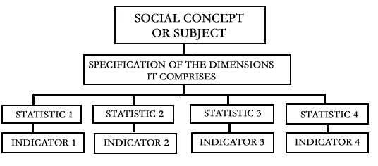
- Operationalize these dimensions, identifying their corresponding variables

- Elaborate a list of relevant indicators for these variables, identifying their corresponding statistics and the way to construct indicators out of them

- Carry out a diagnosis of available sources for the construction of indicators:
- Evaluate which are viable (valid, reliable and available)
- Identify which indicators that are not available are important for the system (it may be possible to collect them from some source in the future and incorporate them in the system)

- Construct the system based on selected indicators

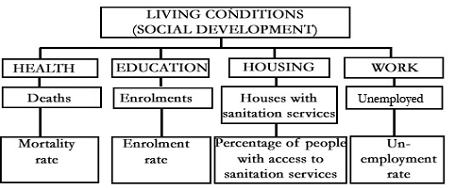
An example of dimensions, statistics and indicators of a system:

A system of indicators needs a balance between the dimensions and indicators that it comprises. Indicators must be mutually consistent (non-contradictory information, compatible sources) and appropriately weighted within the system (according to the relevance of the indicators included to characterize the phenomenon).

PART TWO:
The Work of Social Watch

4. DEVELOPMENT INDICATORS FOR INTERNATIONAL MONITORING

- Using objective indicators Social Watch has always geared its efforts to measuring governments’ achievement of targets set by themselves at different international forums:

1995: World Summit for Social Development (Copenhagen)
Fourth World Conference on Women (Beijing)
2000: Millennium Development Goals.

Consequently Social Watch Reports are a tool that people the world over can use to make their governments, the UN system and international organizations accountable.

- In 2004 Social Watch incorporated into its annual reports the Economic, Social and Cultural Rights (ESCR) perspective whereby States must:

- Respect, Protect and Establish Human Rights
- Allocate the maximum resources available to the progressive establishment of human rights (Art. 2 ICESCR)
- Provide information to the United Nations ESCR Committee

  - The Social Watch follow-up strategy is built around a set of basic areas of social development that represent relevant thematic areas for understanding poverty from a multi-dimensional perspective.

Thematic areas

Poverty and distribution
Food security
Education
Health security (Morbidity and mortality, Immunization)
Environment
Gender equity (In education, In economic activity, In empowerment)
Reproductive health
Information, science and technology
Public expenditure
Development aid
International commitments and human rights

5. PRESENT SITUATION AND PROGRESS IN SOCIAL DEVELOPMENT DIMENSIONS

- Social Watch has developed a system of indicators, based on the selected thematic areas, to evaluate countries’ social development situation and progress.
- Indicators selected to define and evaluate these core areas of development respond not only to conceptual criteria but also to functional considerations based on an evaluation of coverage and the international comparability of indicators.

The position of countries in each thematic area

- The situation a country is in, according to each indicator, is given by the latest available value for that indicator.

- Each country is assigned a value from 1 to 4 (1 indicates the worst situation and 4 indicates the best situation) according to its values on each indicator, and an average of these values is then given for all the indicators in that area. In this way a self-referential ranking is obtained, independent of distance from goals or from specific conceptually-defined levels.

- Values obtained from all the indicators of one area are gathered in one scale, out of which the four possible country categories are created, based on average values for that thematic area:

- Countries in best situation
- Countries above average
- Countries below average
- Countries in worst situation
- A fifth category comprises - Countries with insufficient data to summarize the area.

Progress or regression? Rate of change

- The rate of change for each country is obtained by considering the indicator value variation over the time period within which measurements were made. The quotient from the indicator variation and the time period reflects the rate of change for the item in question.

- When the initial data is for a period (e.g. 1990-1994), the mid point is taken (e.g. 1992) to calculate the rate of change

- The average values were rescaled to create five categories:

  - Significant progress (countries progressing at a higher rate than the average rate of progressing countries)
  - Slight progress (countries progressing at a lower rate than the average rate of progressing countries)
  - Stagnant (countries not showing significant progress or regression)
  - Slight regression (countries regressing at a lower rate than the average rate of regressing countries)
  - Significant regression (countries regressing at a higher rate than the average rate of regressing countries)
Presenting the thematic tables:
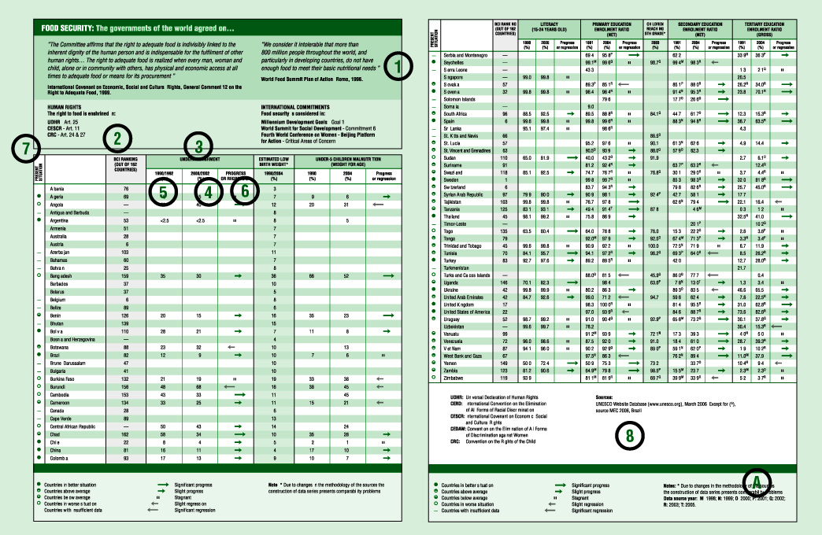

- Heading: For each area of social development, the related commitments assumed at the social summits are linked to the corresponding human rights treaties. In both cases, these instruments have the near-unanimous approval of the world’s governments, given that the majority have signed and/or ratified them.
- BCI ranking: Presents a ranking of countries (from 1 to 162) based on their scores on the Basic Capabilities Index (BCI), a measurement designed by Social Watch that evaluates country status with regard to the basic conditions of development. (For more information about the BCI, see Basic Capabilities Index) Countries with the highest BCI scores are listed first.
- Indicator: Each thematic area includes indicators that are pertinent to evaluating the dimension in question and for which information is available from a large number of countries. This makes it possible to visualize the situation in each country while comparing the distances between them.
- Present situation: This column presents the latest data available for each country according to the source consulted. These figures allow us to evaluate and compare the present situation in the countries of the world. Given that in many cases, the latest available figures are not up to date, it is important to take into account the time period to which the data correspond (if data do not correspond to the time period listed in the heading, they are identified with a letter that refers to a note at the bottom of the page. See Notes “A”).
- Initial data or starting point: This column presents the available information from as close as possible to 1990 (the year that is taken as the starting point in the international commitments that set quantitative goals in different aspects of social development). For some indicators, the reference year (indicated in the heading) is later because sufficient information for 1990 was not available. (As in Present Situation, data from periods different from those listed in the heading are identified with a letter that refers to a note at the bottom of the page. See Notes “A”).
- Progress or regression: Based on current and initial data, the rate of progress or regression over the intervening time period is calculated for each country, taking into consideration the evolution of all of the countries in this indicator. The result is expressed graphically (See the related note at the bottom of the page), facilitating the reading and evaluation of performance in the indicator during this period. The possible categories are: Significant regression, Slight regression, Stagnant, Slight progress, Significant progress.
- Category of present situation: This column illustrates the present situation of the countries in the corresponding dimension through a summarizing measurement that evaluates countries based on their performance on the set of indicators included for which information is available . The categories are: Countries in better situation, Countries above average, Countries below average, Countries in worse situation.
- Sources: The information used for the indicators is obtained from recognized international organizations that compile the statistics produced by the countries.

6. A HUMAN RIGHTS PERSPECTIVE

The thematic tables include two kinds of tools that make it possible to carry out a supplementary analysis of social development from a human rights perspective.

- References to social development goals and Economic, Social and Cultural Rights (ESCR) related to each area facilitate the articulation of each international social commitment with the corresponding article of a specific human rights international instrument. As both of the related instruments have been ratified by a majority of countries in the world it is thus made clear, in terms of legal obligation, just what is involved in meeting development goals.
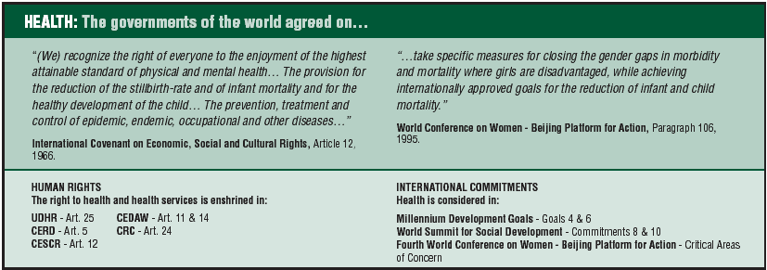
This articulation makes it possible to show how international commitments made at United Nations conferences have a legal force that goes beyond the mere political will of any single government. It follows that food security, universal access to education, improved health services, access to reproductive health services, access to information, a clean environment, adequate housing and gender equity are all human rights that must be provided for and protected.

- Analysis of internationally comparable basic indicators and their evolution in each country, based on Article 2 of ICESCR to evaluate ESCR situations and progress:

PROGRESS AND ABSENCE OF REGRESSION:  The evolution of specific plans and processes implemented by governments to gradually provide for the exercise of rights can be monitored using indicators that demonstrate the results of these initiatives. Social Watch tables show progress or regression in citizens’ quality of life through the evolution of their indicators.  When a country is shown to have regressed in an area in which it has made a commitment to international development goals it is clear that that country is failing in its obligation to make progress towards providing for a particular right. These indicators do not in themselves indicate rights violations and have to be supplemented with other kinds of evaluation that capture the actual specific process involved in each case. However, regression in one Social Watch indicator signals that rights violations may be taking place. |  | NO DISCRIMINATION: Governments have made commitments to guarantee that rights are exercised by all members of society (ICESCR, CEDAW , International Convention on the Elimination of All Forms of Racial Discrimination). On the question of gender discrimination Social Watch does systematic follow–up on the situation in each country using thematic gender equity tables (education, economic activity and empowerment) and constructs a Gender Equity Index.
 |  | MAXIMUM RESOURCE COMMITMENT: Governments are obliged to commit the maximum resources available to guarantee the exercise of basic rights. In this context Social Watch has constructed a thematic table on Public Expenditure that shows the evolution of public spending on health and education as a percentage of GDP.
7. BASIC CAPABILITIES INDEX (BCI)

It is an index focused on the minimum or basic capabilities essential for social development.

This index was based on the methodological approach adopted by Social Watch Philippines in their 2001 Report, and Social Watch has been using this country evaluation tool since 2004.

BCI reflects basic well-being gauged by capabilities in different aspects of the human condition, and the indicators that comprise it yield separate results for each dimension. The index gives an efficient rating for the basic levels of people’s well-being on the basis of their state of health (child health and reproductive health) and their performance in primary education. Both these dimensions are of crucial importance in development goals.

CONCEPT MINIMUM SOCIAL DEVELOPMENT

Under-five mortality rate
INDICATORS Births attended by skilled personnel
Children who reach the fifth grade of primary education

INDEX BASIC CAPABILITIES INDEX (BCI)

- Low BCI values indicate that the country in question is far from providing for people’s basic needs, so the first positions are occupied by countries where improvement is urgently needed and is indeed essential if a minimum level of well being is to be attained.

- BCI has comparative advantages in that it is relatively simple to calculate and is inexpensive because it does not depend on household surveys to estimate levels of income. It is compatible with the various national and international statistical systems, and it can be calculated easily from indicator data that is regularly issued by governments and agencies.

- It can be used for classifying the relative situation of countries or of particular sectors within a country (population groups or geographical areas, for example),

- It can be used to generate historical series for monitoring situations connected to poverty.

- BCI facilitates differentiation between countries in unfavourable situations, but it is less sensitive for detecting differences between countries that have reached a relatively high level of development. This is because the indicators used relate to a lack of basic capabilities characteristic of unfavourable development situations. Therefore, as a tool, it is more suitable for identifying critical situations than for detecting slight differences between more developed countries.
8. GENDER EQUITY INDEX (GEI)

It is anindex for the analysis of gender equity. Its construction involves three dimensions: education, economic activity and empowerment

The Gender Equity Index (GEI) has been produced by Social Watch since 2004 and has subsequently been revised and improved with the aim of developing a tool to capture the degree of gender equity prevailing in a country. The index has been built up from internationally available information on dimensions that affect gender equity.

- Within each dimension the gap between women and men in each of the index’s indicators is calculated thus making it possible to evaluate how far each country currently is from an optimum situation in which there are no gender gaps at all.

- The 2006 version of GEI provides a simple average of the gaps in the three selected dimensions.

Dimensions and indicators:
- Empowerment (% of women in technical positions, % of women in management and government positions, % of women in parliaments, % of women in ministerial posts).
- Economic activity (income gaps, % of economically active women (excluding the agriculture sector).
- Education (literacy rate gap, primary school enrolment rate gap, secondary school enrolment rate gap, tertiary education enrolment rate gap).

CONCEPT GENDER EQUITY

INDEXES Empowerment gap
BY AREA Economic activity gap
Education gap

GLOBAL GENDER EQUITY INDEX (GEI)
INDEX

- The values used in GEI range from 0 to 1 (for easier reading a base of 100 is usually employed).

- Lower values on the index indicate a greater degree of gender inequality in the country in question, and countries with values nearer to 1 are those that have reduced gender inequity the most.

- It is important to bear in mind that the values in the index reflect only the dimensions and indicators employed. No index could yield a complete picture of a phenomenon as complex as gender equity but it is possible to be sensitive to the different situations involved and detect the ways in which these are changing.

Social Watch holds a critical view on how the goals established by the UN in the Millennium Summit are being operationalized, as this process has focused on countries in the worst relative situations, thus reducing expectations and demands for improvement in other countries with higher relative development. However, the Millennium Development Goals (MDGs) are considered an important point of reference.
There are significant difficulties involved in obtaining data with sufficient coverage and international comparability and in addition a lack of homogeneity in dates, differing data construction methodological criteria between countries and even discrepancies in data from different international sources.
For this, the variable was normalized (by subtracting the mean and dividing by the standard deviation) and then the mean positive values and the mean negative values for the normalized indicator were calculated. The four categories were established according to the values above and below the mean positive values for the normalized indicator, and the values above and below the mean negative values for the normalized indicator.
ICESCR, Article 2: “Each State party to the present Covenant undertakes to take steps, individually and through international assistance and co-operation, especially economic and technical, to the maximum of its available resources, with a view to progressively achieving the full realization of rights recognized in the present Covenant by all appropriate means, including particularly the adoption of legislative measures. The States party to the present Covenant undertake to guarantee that the rights enunciated in the present Covenant will be exercised without discrimination of any kind as to race, colour, sex, language, religion, political or other opinion, national or social origin, property, birth or other status.”
Convention on the Elimination of All Forms of Discrimination Against Women.
Raya, R. (2001). An alternative measure of poverty and human capability: Introducing the Quality of Life Index. Social Watch Philippines. Report 2001. The Quality of Life Index, originally developed by the Philippine non-governmental organization Action for Economic Reforms, is derived from the Capability Poverty Index (CPI) dev eloped by Professor Amartya Sen and popularized as the United Nations Development Programme’s Human Development Index (HDI).
In the 2004 report it featured as the “Quality of Life Index”. This title was changed in 2005.
One difference between the BCI and the HDI is that the latter combines capability indicators with income measurement.
The main obstacle to constructing a comprehensive tool that is based on a selection of indicators and is conceptually suitable for measuring gender inequities is that in many countries basic information is scarce.
The three dimensions have an equal weight in the index

