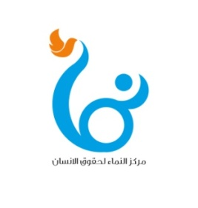
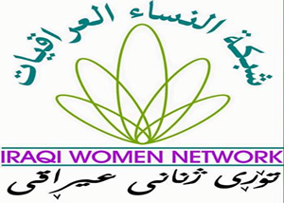

Statement of solidarity with the people of Basra
and their legitimate demands

Iraqi Women Network (IWN) and Al-Namaa Center for Human Rights expresses deep concern over the catastrophic environmental, health and economic situation in Basra governorate, which resulted from the inadequate federal and local government policies, neglect and rampant corruption in state apparatus, This started the peaceful demonstrations by young people on the 13th of last July, which evolved to a social protest movement including all social categories of Basra people demanding that the decision makers in the federal and local government hold the corrupt accountable and improve the basic services and living standards of citizens.
While expressing our full solidarity with the legitimate demands of the protest movement in Basra, we express our heartfelt condolences to the families of over 20 martyrs, as well as to the wounded as a result of the brutal attacks against the peaceful demonstrators. At the same time, we condemn the practices of intimidation, threats and silencing of demonstrators and civilian activists, which constitute a flagrant violation of the freedom of expression, the assembly and peaceful demonstration guaranteed by the Iraqi Constitution. We also salute in particular the women activists from Basra who participated in the protest movement, challenging the campaign of smear and threats.
Achieving stability and security in Basra will not be achieved through futile promises. Rather, immediate measures are needed to address the chronic problems of Basra that provides most of the financial sources of the state budget by working on:
- Support the demands of the demonstrators during the last two days by dismissing the Basra Operations Commander and to hold accountable those who insulted the peaceful demonstrators, and the urgent exposure of the killers of the demonstrators and all those who have been proven to be involved in violence during popular protests and take legal action against them , compensation of the families of the martyrs and the provision of medical support to the injured by relevant state agencies.
- The security services shall protect the peaceful demonstrators and the civilian activists against aggression and threats and build bridges of trust and cooperation between the citizens and the security forces within the framework of respect for human rights, the rule of law and the preservation of state institutions.
- Accountability of officials accused of corruption, and the development of effective plans for the reconstruction of the governorate, and provide basic services to citizens, especially addressing the crisis of water salinity and pollution.
- Open cooperation and coordination between government authorities and civil society organizations and human rights defenders, including youth leaders and representatives of the feminist movement to achieve partnership and social control in the implementation of plans to address the chronic problems in the province.

Baghdad on September 12, 2018

