Workshop Agenda:
"Building an Asian Community of Practice on
Monitoring and Budget Analysis"
9 – 11 July 2007 Phnom Penh, Cambodia.
2nd Floor of the Cambodiana Hotel in the Tonle Bassac Hall

Organized by SILAKA and Social Watch
in collaboration with OXFAM- Novib/KIC

Sunday, July 8, 2007
7:00 pm to 2:00pm | Arrivals
2:00PM to 3:00pm | Distribution of workshop materials
6:00pm to 8:00 pm | Welcome reception( introduction of participants)

Monday, July 9, 2007
7:30am to 8:00am | Continental Breakfast
8:00am to 9:00am | Registration
9:00am to 10:00am | Official Opening and Overview of the Workshop
10:00am to 10:30am | Morning Break
10:30am to 12:00pm | Presentation: Workshop objectives and expectations
12:00 pm to 1:30 pm | Lunch Break
1:30 pm to 3:00 pm | Presentation: ESCR Approach  Facilitator: Claire Mahon
3:00 pm to 3:15 pm | Afternoon Break
3:15 pm to 4:45 pm | Group Work and Discussion
6:00 pm to 8:00 pm | Evening Reception

Tuesday, July 10, 2007
7:30am to 8:00am | Continental Breakfast
9:00am to 10:30am | Presentation: Monitoring  Facilitator: Maria Luz Anigan
10:30am to 10:45 am | Break
10:45am to 12:00pm | Group Work and Discussion
12:00 pm to 1:30 pm | Lunch
1:30 pm to 3:00 pm | Presentation: Budget and Analysis  Facilitator: Prof. Briones
3:00 pm to 3:15 pm | Break
3:15 pm to 4:45 pm | Group Work and Discussion
6:00 pm to 8:00 pm | Evening Reception

Wednesday, July 11, 2003
7:30am to 8:00am | Continental Breakfast
9:00am to 10:00am | Opening Ceremonies
10:00am to 10:30am | Morning Break
10:30 am to 12:00 pm | Presentation: Advocacy/Social Indicators –The Social Watch experience  Facilitators: DANIEL MACADAR, DANIEL CIGANDA and IGNACIO PARDO
12:00 pm to 1:30 pm | Lunch Break
1:30 pm to 3:00 pm | Conclusions, and Evaluation
3:00 pm to 4:00 pm | Afternoon Break
4:00 pm to 5:30 pm | Closing Ceremonies
6:00 pm to 8:30 pm | Evening Reception
Thursday, July 12, 2007
8:00-12:00 | Departures

Workshop Location

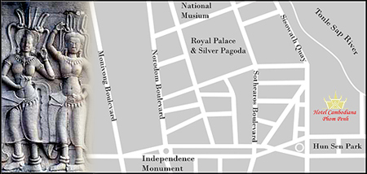

Hotel Cambodiana
313 Sisowath Quay,Phnom Penh, Kingdom of Cambodia.
Tel: (855) 23 218-189 / 426 288
Fax: (855) 23 426 392
Email: luxury@hotelcambodiana.com.kh
Internet: http://www.hotelcambodiana.com

