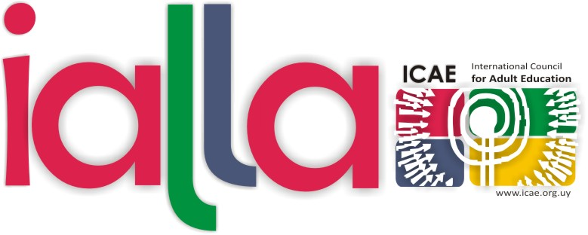

VIII ICAE ACADEMY OF LIFELONG LEARNING ADVOCACY (IALLA)

CALL FOR APPLICATIONS

Date: October 13-26, 2014

Venue Madaba, Jordan

Cost: 2.000 Euros (board, lodging, tuition costs) + airfare cost
Note: A limited number of scholarships (either full or partial) are available for applicants from developing countries.

Deadline to apply: July 15, 2014

Organized by: International Council for Adult Education (ICAE) in partnership with dvv
International.

Supported by: Swiss Development Cooperation

The ICAE Academy of Lifelong Learning Advocacy (IALLA) is an international training course held for the first time in 2004, in Norway. Since then, a total of seven editions have taken place in Africa, Arab Region, Europe and Latin America; and in 2012 the first advanced, second stage IALLA was held. Until now, there are 189 IALLA graduates from 68 countries.

General objective

To give emerging leaders in adult learning and education (ALE) and social movements, the opportunity to acquire the skills to advocate for the right to adult learning and education and to consolidate ICAE as a global network committed to that end.

Specific objectives

1. To generate a broader vision on youth and adult education within the framework of human rights and active citizenship, developing linkages with the most important issues of the current global context.
2. To support the emergence of a new leadership able to learn from diversity and to do networking, so as to secure the regeneration of ICAE, in particular, and of the education movement in general.
3. Increase participants’ abilities to advocate and network for inclusive education, lifelong learning and issues of relevant concern in their organizations and fields of work.

4. To follow-up and facilitate the exchange among participants to promote the continuity of the learning process by sharing their own experience after IALLA course.

Principles

The definition of the contents take into account the new learning needs emerging from the current global context.

At a time in which the current globalization model is characterized by uncertainties, a contribution of the course is to enable participants to better understand the complexities and their impact and to develop their capacities in building inclusive solutions through different and creative perspectives.

The course presents networking as a suitable mechanism for collective learning. International teamwork allows for the recognition of differences and the generation of synergies among different visions and skills. It also has the capacity to generate new solutions and the subsequent advocacy to promote change in the public policies at all levels.

The course promotes a dynamic and proactive attitude of the participants; and taking into account the unprecedented global changes, the course highlights the challenge that there are no unique answers, instead, there is an urgent need to creatively engage in different forms of lifelong learning and advocacy.

Course description and methodology

The course is structured to provide a coherent learning process. The curriculum covers a range of core and solid contents and tools, teamwork, and the analysis of practical experiences and innovative projects.
The course applies a participatory methodology whereby participants are encouraged to be active and dynamic, making contributions in the sessions and in group work. These sessions, combined with lectures and open debates led by a group of experienced and high-level experts from different regions, will train participants to work as a professional global team.

Themes that will be dealt with at the course are:

Human Rights
- Economic, Social, Cultural and Environmental Rights. Education as a human right.
- Discussion of the concept of adult education, lifelong learning.

Civil Society and Democracy
- Discussion of the concept of civil society and state.
- Origins of the concept of citizenship and active citizenship.
- Education for democracy and sustainable development.
- Popular education and education for inclusion.

Global Movements and Networks
- History of the Global Movements.
- World Social Forum and new social movements.
- The action of civil society as an educational process.

UN Post 2015 Development Agenda and Sustainable Development Agenda
- The Post 2015 development agenda, MDGs, EFA and CONFINTEA.
- Rio+20 process: education for sustainability. The education we need for the world we want.
- Creative participation and strategies for advocacy. Intersecting agendas.

Requirements
The program is open to applicants who meet the following requirements:
- ability to communicate (oral and writing skills) in English. (No translation will be available)
- availability to attend the whole course (from October 13-26, 2014)
- advocacy experience
- activism in the adult learning and social movement’s field
- networking skills
- graduates or equivalent education or advanced students
- priority shall be given to young leaders
- priority shall be given to ICAE members
A criteria of gender balance will be applied.

Application process
Applicants should submit the following documents:
- Application form and curriculum vitae (not more than 4 pages) should be sent by electronic means to: icaeialla@gmail.com

- Letter of recommendation from one referee should be sent by email: icaeialla@gmail.com (in letterhead sheet and with scanned signature) or by Fax: (598-2) 409 79 82

The deadline for the receipt of application form, curriculum vitae and referee letter of recommendation is: July 15th, 2014
Only selected applicants will be notified about the selection by the end of July. A formal letter may be sent, upon request, for the institution where you are applying for a scholarship.

Please note: Application forms, curriculum vitae or letters of recommendation which are hand-written, incomplete, submitted after deadline, or which are not in English language, will not be accepted.

