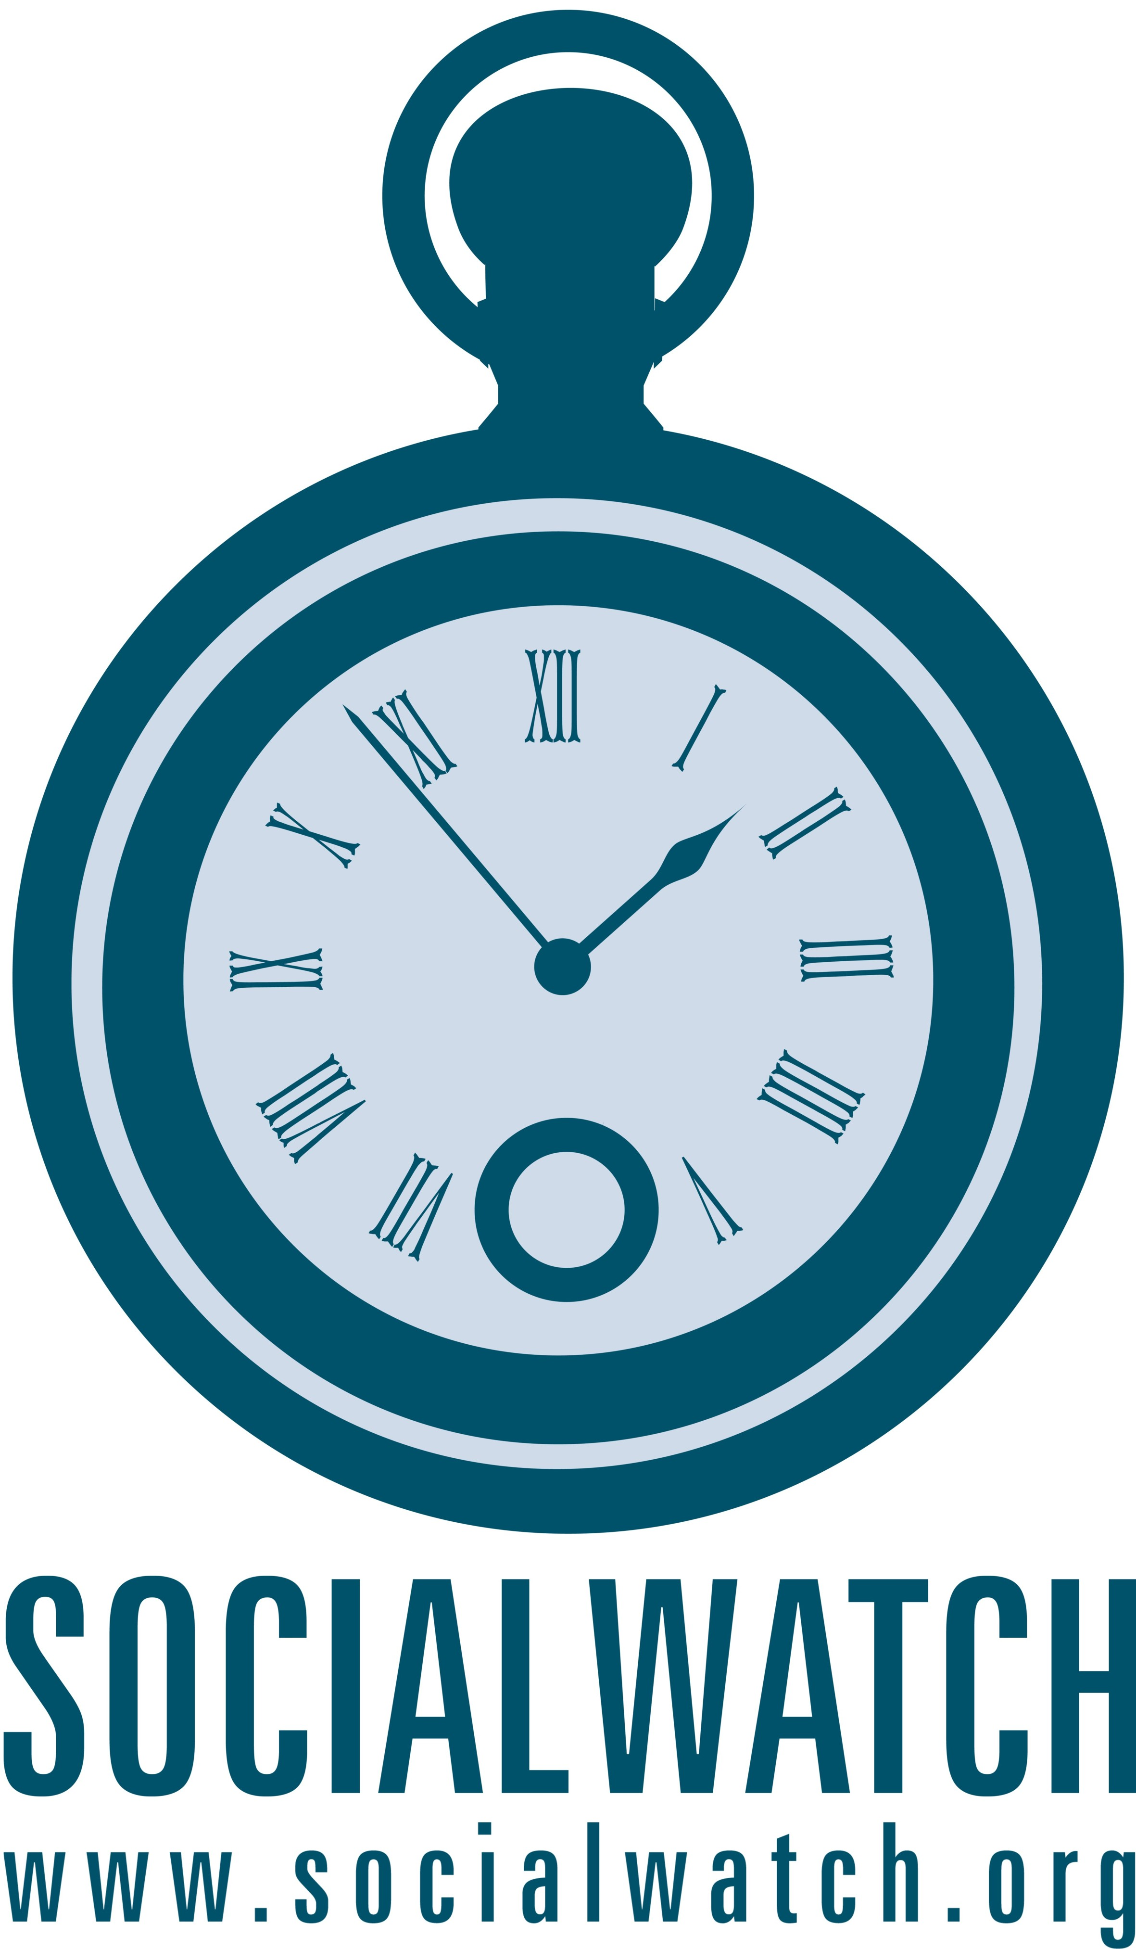 | Outline  Social Watch General Assembly Accra 2009  Thematic Workshop on the Systemic Crisis and Alternative Solutions by Civil Society: Key International Commitments for the Promotion of Gender Equality and Women’s Rights’.

In this workshop we want to address all the critical issues relating to the financial crisis and its implications for gender equality and women’s rights promotion. In the past 12 months governments have responded to the crises through a series of international meetings. Existing mechanisms like CEDAW and the Beijing Conference’s anniversary (Beijin 15) are available to us as opportunities for mobilization on the crisis and civil society has also moved forward with their own policy alternatives. Are these measures sufficient to address the root causes of the crisis and to overcome its social consequences and exacerbation of inequality, injustice and imbalances? How should Social Watch respond? This workshop will include a presentation on the systemic crisis and alternative solutions proposed by civil society as well as key international commitments for the promotion of gender equality (especifically CEDAW). It will also include a brief practical informative presentation on how the Convention on the Elimination of all Forms of Discrimination Against Women (CEDAW) is being utilized in Europe. It will also address the need to ratify the CEDAW Optional Protocol and make it a mandate of the Committee on Economic, Social and Cultural Rights (CESCR) to monitor its implementation by its States parties. CESCR and how the process can be used in the time of crisis.
With our workshop we want to take stock of the Alternative Solutions by Civil Society to the systemic crisis and key International Commitments for the Promotion of Gender Equality and Women’s Rights
We will inform each other about the related activities of Social Watch at global and national levels.
We will discuss goals, objectives, emerging opportunities and strategies for Social Watch in this area for the years 2010 and 2011.
And finally, we will draft a work plan, and a structure of a Thematic Task Team on Gender and Women’s Rights and the financial crisis for Social Watch. We will also build on the Social Watch calendar and include additional opportunities in the policy area and/or mobilization dates and venues (national, regional and global) in the coming 2 years (2010-2011).

Programme Outline
(we have three hours for the workshop)
Duration | Theme | Methodology
1 h | Information
20 min | Update on the state of the CEDAW and its complaint mechanism for protection of women' s rights and alternative solutions by civil society | Mrs. Dorcas Coker-Appiah, facilitated by Emily Sikazwe
20 min | Update on SW activities related CEDAW in Europe and use of CEDAW as a complaint mechanism | Presentation by Genoveva Tisheva
30 min | Update on SW activities on CEDAW and alternative civil society solutions and the financial crisis at the national l level | Oral reports by all workshop participants  Facilitated by Milena
50 minutes | Brainstorming
 | Expectations of participants on the future role and strategy of Social Watch on CEDAW, Beijing +15, alternative civil society approaches and the financial crisis:  - What are our goals and objectives  - What is our key messages  - What are our target institutions  - What is the added value of our work (complementarity to other networks)  - How to link global and national advocacy | Metaplan methodology  Facilitated by Tanya Dawkins
1 h | Planning
30 min | Social Watch Advocacy Strategy on CEDAW, Beijing +15, alternative civil society approaches and the Financial Crisis 2010-2011:  - key events (draft a workplan)  - key objectives  - key activities | Moderated discussion  Moderator Rose Kutin
30 min | Workplan and working methods of a Social Watch Thematic Task Team on Gender and Women’s Rights:  - composition/membership  - Forms of communication (mailing list etc.)  - Activities (research, advocacy etc.)/meetings/output 2010-2011  - division of labour: SW representation in other networks | Moderated discussion  Moderator Emily Sikazwe
05/10/2009

