
GENERAL ASSEMBLY FACEBOOK
ACCRA, GHANA – OCTOBER 2009

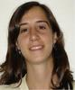
ARGENTINA - Laura Royo

Lawyer of the Economic, Social and cultural rights program (ESCR program) at the Centre of Legal and Social Studies (CELS).

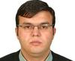
AZERBAIJAN – Kenan Aslanli

Economist – policy researcher at the Public Finance Monitoring Center, teacher at the Academy of Public Adminstration, key local expert of the International Budget Project (USA).

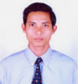
CAMBODIA-Sak Sothea

Mr. Sak Sothea has extensive experience in providing services and capacity building for government official and staff of NGOs at national, provincial and local level. He has also built his expertise in gender and womens empowerment through political participation, and local economic promotion through innovative regional management.


CENTRAL AFRICAN REPUBLIC-Rodonne Siribi

I'm Central African, Responsible of NGO GAPAFOT. I work with all people to restore hope for the most vulnerable peoples.

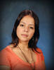
COSTA RICA-Adriana Sanchez

Adriana Sanchez, Sociologist, University of Costa Rica, where she serves as part of the Training Program for Local Development and is part of the Social Watch Network.

GUATEMALA-Helmer Velásquez
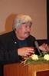
Attorney and Notary Public with a Masters in Social Sciences. His experience is related to social development, NGOs and rural issues. He is currently Director of the Coordination of NGOs and Cooperatives-CONGCOOP, and Legal Adviser for Rural and Social Movements.

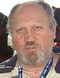
HUNGARY-Matyas Benyik

Matyas Benyik has a Degree in Business Administration and a Masters in International Economic Relations from the Karl Marx University of Economic Sciences in Budapest. Since 2002 he has been a member of Attac Hungary, and currently serves as President of the organization.

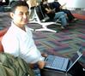
INDONESIA-Mohammad Firdaus

Mohammad Firdaus is Deputy Director of ASPPUK. He holds a Masters Degree in Sociology from the University of Indonesia.

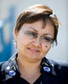
MONGOLIA-Undral Gombodorj

Director of the Democracy Education Center (DEMO), National Coordinator for Civil Society Council. She has a Master’s Degree in Economics from the Institute of Economics of Prague, Czech Republic. She has worked for over 15 years in the NGO sector. She is a certified trainer, facilitator, researcher, and author of numerous publications on NGO management and democracy education topics.

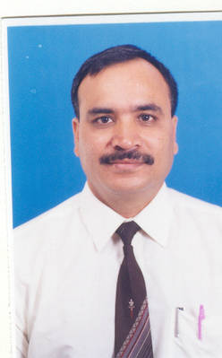
NEPAL-Sarba Raj Khadka

Director of Rural Reconstruction Nepal (RRN), Founding Member and currently Secretary General of National Alliance for Human Rights and Social Justice (HR Alliance), Nepal, Secretary of FIAN Nepal Chapter, Founding Member and Programme Coordinator of South Asia Alliance for Poverty Eradication (SAAPE). He has more than 25 years of professional experience in diverse fields of human rights, development and related campaigns on people's issues. In addition, he has a doctorate in natural resources management from the Asian Institute of Technology (AIT), Thailand.

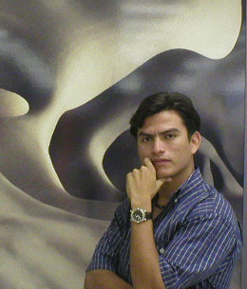
NICARAGUA-Fidel Moreira

Coordinator of the Civil Coordination (Umbrella group of NGOs) in Managua. He holds a degree in Social Anthropology from the Universidad Autonoma de Nicaragua. He is also the Treasurer of the Executive Board of the Nitca Foundation.

NIGERIA-Luke Chukwuka

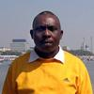
Board Chairman, Social Watch Initiative, Nigeria.

PARAGUAY-Roberto Villalba

Psychologist, with studies in sociology, founder of the NGO, Paraguayan Data Bank, which closed in May 1983. Later, he founded the Center for Documentation and Studies (CDE), and is currently an Area Coordinator at CDE.

PHILIPPINES-Marivic Raquiza

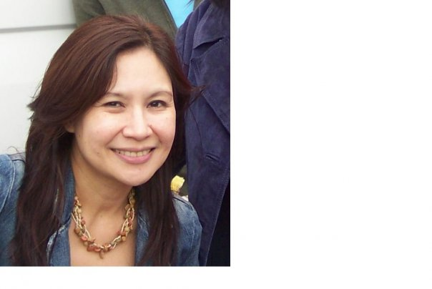
Marivic Raquiza is Co-Convenor of Social Watch Philippines and a Board Member of Justice Associates. She was the National Coordinator for the Global Call to Action Against Poverty from 2005-2007, and a member of GCAP's International Facilitating Team. She was assistant vice-president of the Philippine Rural Reconstruction Movement, and has conducted numerous gender assessments for various NGOs. She holds an MA in Development Studies from the Institute of Social Studies (ISS) in The Hague, and is currently an assistant Professor in the University of the Philippines where she will be teaching courses on poverty, social development and social change.


POLAND-Katarzyna Szymielewicz

Lawyer, director of Panopticon Foundation, member of the Polish Section of International Commission of Jurists and Polish Social Watch coalition, independent NGO consultant. At present cooperates with the Helsinki Foudation for Human Rights, Amnesty International and International Commission of Jurists on projects covering business and human rights, observance of human rights standards in counter-terrorism policy and surveillence society issues.


POLAND-Magdalena Pochec

Magda joined KARAT in January 2008 where she coordinates the project titled Promoting Social Development: Building Capacities of the Polish Social Watch Coalition. Cross-cultural and gender psychologist by training, she also completed postgraduate Queer Studies. Her major expertise area is sexual and reproductive health rights, especially regarding transgender people. In October 2007 - October 2008, Magda was Vice-chair of YouAct, European Youth Network on Sexual Rights. Magda coauthored the shadow report on the status of women in Poland submitted to the CEDAW Committee for its 38th Session in January 2007.


ROMANIA-Diana Berceanu

Sociologist working within Civil Society Development Foundation(CSDF) Romania, Bucharest as Director of the Development Department. Involved in developing researches about the state of the NGOs sector in Romania.

SENEGAL-Seydou Ndiaye

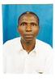
Program Officer - NGO ACAPES- Senegal SP Working Group for the Promotion of Citizen Monitoring of Public Action. He holds a University Diploma of Scientific Studies of the University Cheikh Anta Diop in Dakar, and has a twelve year teaching career on the university level. He has trained senior technicians in planning and organizational management from the Ecole Nationale d'Economie Appliquée (ENEA). As Program Officer of ACAPES, he works in coalitions and networks of organizations of civil society.

SOMALIA-Mohamoud Ossoble
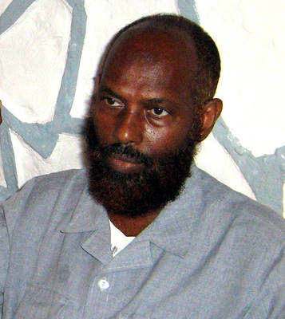
Born in Mogadishu , Somalia in 1955, Ali Mohamoud Ossoble attended primary and secondary education in the Somali capital. He later attained higher education qualifications from Sana’a University in Yemen and now is the Resource Centre Manager and Trainer with the Somali Organisation for Community Development Activities, SOCDA. Mr. Ossoble compiled the 2009 SW Somalia Report and is looking forward to its launching in December during the Somali Social Forum.

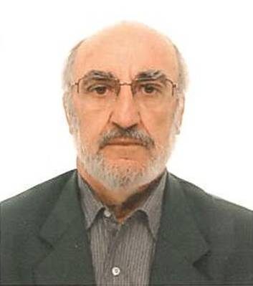
SPAIN-Carlos Rodriguez

Carlos is the director of international cooperation programs IEPALA
(Institute of Political Studies for Latin America and Africa), Member of
Platform 2015 and More. Carlos has been involved in international cooperation for over 30 years. He has experience working in Latin America, Africa, Middle East and Asia.

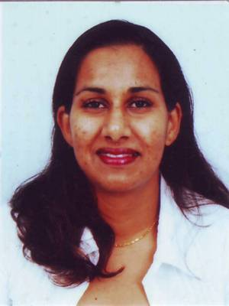
SURINAM-Gitanyaly Girjasin
She is a Sociologist from the Anton de Kom University of Suriname, with a daughter of 3.

SYRIA-Ammar Qurabi

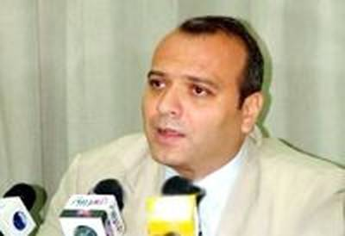
Chairman of the National Organization for Human Rights in Syria, he was a co-founder of the Committees for Reviving Civil Society in Syria and began doing human rights work in 2000. He is the Coordinator of the Association of Non-Governmental bodies in Syria, "Syrian Platform".

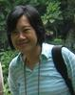
THAILAND-Ranee Hassarungsee

Secretary and Coordinator of Social Agenda Working Group, Chulalongkorn University Social Research Institute.

UGANDA-David Obot

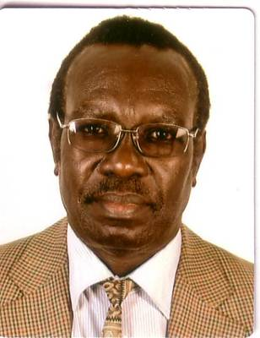
David Obot is currently the Executive Director, Network of Ugandan Researchers and Research Users (NURRU), a national NGO based in Uganda. NURRU's research activities are in Uganda and the East African region. David coordinates consultations and the production of the Uganda Social Watch report. He is also on the Social Development Sector Working Group, Uganda's Ministry of Gender, Labour and Social Development; and a member of the Social and Human Sciences Committee of UNESCO Uganda.

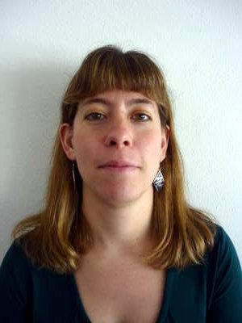
URUGUAY-INTERNATIONAL SECRETARIAT-Jana Silverman

Jana Silverman is Campaigns and Communications Coordinator at the Social Watch International Secretariat in Uruguay. Previously she worked as a project coordinator and researcher at the National Trade Union School in Medellin, Colombia. She holds a Masters in International Affairs from Columbia University. She is also a ranked foil fencer in Uruguay and a delegate of the SUTIGA-FUECI trade union.

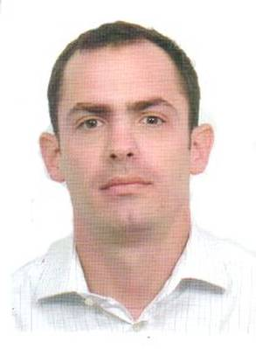
VENEZUELA-Antonio Puppio

He is a practicing lawyer since 2001 in Caracas, Venezuela. He has worked at Provea since 2006, and since May 2009 coordinates the DESC program at the organization. He is also a researcher and editor of the social security chapter of the Annual Report on the human rights situation in Venezuela, a publication that has been produced for over 20 years.

