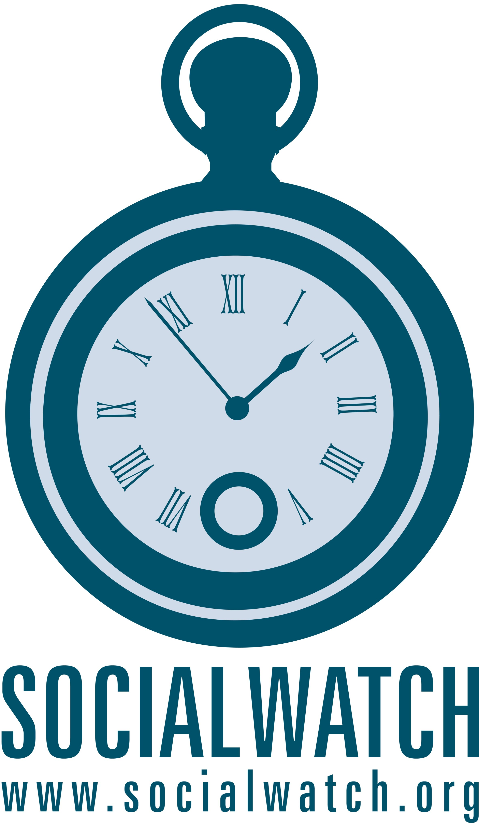 | Outline  Social Watch General Assembly Accra 2009  Thematic Workshop on Social Indicators

(Reference Group for Workshop Design: Jana Silverman, Himanshu Jha, Jeck Cantos, Fernanda Carvalho, Jason Nardi)

Social indicators are key tools for validating the effectiveness of public policies and for tracking the progress or regression towards certain social goals, including the UN commitments that Social Watch was mandated to monitor. The use of indicators also allows civil society to conduct comparative analyses of social conditions in different geographical areas, and to identify populations in situations of vulnerability, thereby assisting in the design of stronger, more coordinated policy responses. Social Watch has a rich history both on the national and global level of constructing innovative methodologies which allow us to better use existing social indicators and to construct new indices that more accurately reflect social realities linked to economic, social and gender rights.

Taking this into consideration, this workshop intends to: frame and analyse the current debates regarding social indicators and their use as a tool to inform public policymaking and campaigning around issues related to economic, social and cultural rights. Present the Social Watch experience related to indicators on both a network-wide and national level. Discuss current challenges faced by civil society actors in the development of work on social indicators, both from a methodological and a socio-political perspective. Share ideas related to the forming of a more permanent space for discussion and action on social indicators, through the creation of the Social Watch thematic working group on this topic. Brainstorm possible activities to be undertaken by the working group, decide on the modalities of communications among the working group memers, and elect the convener(s) of the working group.

Agenda

1) Welcome/presentation of agenda and of participants (workshop facilitator).

2) Presentation on the concept and recent trends regarding the construction and use of social indicators (Himanshu Jha, Social Watch India).

3) Presentation on the experience of Social Watch related to social indicators, and the conceptualization and use of the Basic Capabilities Index and Gender Equity Index (Jana Silverman, Social Watch Secretariat).

Coffee Break

4) Presentation of experiences on the national level related to social indicators:
Social Watch Philippines and the Quality of Life Index (Jeck Cantos, Social Watch Philippines).
Social Watch Brazil and some preliminary experienes in the use of indicators to reflect social and economic inequality (Fernanda Carvalho, Ibase-Social Watch Brazil.).
Social Watch Italy and the construction of social indicators from a developed-country perspective (Jason Nardi, Social Watch Italy).

5) Question and answer session/sharing of experiences on social indicators among all workshop participants (workshop facilitator).

6) Discussion on the creation of the SW working group on social indicators: possible activities, modalities of communication, other actors to involve in the working group, election of convener(s) (Jana Silverman).

