Social Watch

PRESS RELEASE – For immediate publication

Social Watch launchs 2011 Basic Capabilities Index

A lost decade in the fight against poverty

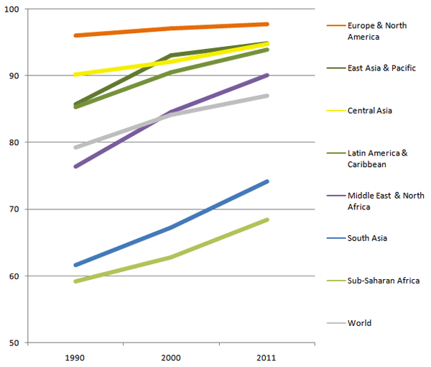The first decade of the 21st century was a lost decade in the fight against poverty, in spite of the excellent performance of the emerging economies, said Roberto Bissio, coordinator of Social Watch, on the eve of the international days on hunger and poverty.

Social Watch, a network of citizen organizations monitoring social policies around the world launched today a Basic Capabilities Index derived from well-being indicators which slows very slow progress in the last twenty years. This index contradicts the assessment of the World Bank, according to which extreme poverty would have halved around the world between 1980 and 2005.

“By looking at basic well-being indicators like malnutrition, child delivery and primary education instead of focusing on income, the BCI is closer to reality than the one-dollar-a-day line of the World Bank”, claims Bissio. The world average inhabitant doubled her income from 4.079 dollars in 1990 to 9.116 dollars in 2011 but the world Basic Capabilities Index barely increased in these twenty years from 79.3 to 87.1 points. A slowdown was registered during the first decade of the 21st century, when the index moved up three points, while progress amounted to five points between 1990 and 2000.

The index computed by Social Watch merges mortality among children under five, which relates strongly with malnutrition, the proportion of births attended by skilled health personnel, and primary education data.

The figures do not allow yet to assess the whole impact of the crisis that started in 2008, since social indicators are gathered and published much slower than the economic numbers. Yet, Social Watch member organizations have already verified in their own countries that the world’s most vulnerable sectors are indeed the ones carrying the largest burden of austerity measures.

Before the crisis, gross income was growing fast while progress in education, health and nutrition was advancing slowly. If industrialized countries enter into a prolonged period of stagnation or recession, the situation of the most vulnerable sectors at global level can only become worse.

The countries holding the top positions in the list according to BCI values this year are Japan, Norway, Netherlands, Switzerland and Iceland. The worst ranked countries are all in Africa: Chad, Sierra Leone, Niger, Somalia and Guinea Bissau.

More information:
The Basic Capabilities Index 2011 (in xls format):
http://www.socialwatch.org/sites/default/files/BCI_country_en.xls
The Basic Capabilities Index 2011 (in pdf format): http://www.socialwatch.org/sites/default/files/BCI2011_eng.pdf
A lost decade in the fight against poverty: http://www.socialwatch.org/node/13749
BCI trends, 1990 to 2011 – Slowing down: http://www.socialwatch.org/node/13754
See the ICB in a interactive map: http://www.socialwatch.org/sites/default/map/map

For more information, contact:
Roberto Bissio
Social Watch Coordinator
Mobile: +336 1111 3971
E-mail: socwatch@socialwatch.org

How the BCI is measured

All the indicators making up the BCI are expressed in percentages and they range from 0 to 100. Under-five mortality, which is usually expressed in number of deaths per thousand children born alive, is expressed as 100 minus that value. So that, for example, a value of 20 deaths per thousand becomes 2% and, when deducted from 100, yields a basic indicator value of 98. Thus, the theoretical maximum value in infant mortality is 100, which would mean that all children born alive survive until they are five years old. Reproductive health takes the maximum value of 100 when all women giving birth are attended by skilled health personnel. Similarly, the education indicator registers 100 when all the adults know to read and to write, and all school age children are enrolled in education and they all attain five years of schooling. These three indicators are then averaged, so the total value of the index will vary between 0% and 100%.

BCI values for 2011 were computed for 167 countries where data are available, i.e. the vast majority among the 193 member states of the United Nations.

Countries with a basic BCI level (98 points and over) have reached a reasonable human development level and most likely have met the Millennium Development Goals way ahead the 2015 deadline.
Countries with a medium BCI level (91 to 97 points) have achieved a certain level of momentum to address key human development concerns and have a fair chance of meeting the MDGs by 2015.
Countries with a low BCI (81 to 90 points) are still struggling to provide basic services for their citizens and will more likely miss the MDGs by 2015.
Countries with very low (71 to 80 points) and critical (below 70) BCI levels will certainly miss MDGs. Most of these countries, particularly those in a critical situation, are experiencing severe economic difficulties, social unrest or wars. Some have just emerged from armed conflict and are still transitioning to normalize government operations and public services.

Basic Data

—Chad is ranked at the bottom of the list, in 2011, along with Sierra Leone, Niger, Somalia and Guinea Bissau. Countries with the lowest BCI values are mostly from Sub-Saharan Africa and South Asia. Afghanistan had the lowest ranking in 2000 and the are not reliable data to make an assessment for 2011.

— Japan, Norway, Netherlands, Switzerland and Iceland are the countries holding the top positions in the NCI list according.

—The global BCI has progressed slower between 1990 and 2011 than between 1990 and 2000. In 1990, the average BCI value (population weighted) for countries with available data was 79.4. In 2000, BCI increased by 4.9 points to 84.3. BCI further increased to 87.1 by 2011, an increment of 2.8 points, lower than the improvement posted in the previous decade.

—Between 1990 and 2011, more countries have achieved basic and medium BCI levels. During the same period, the number of countries with critical BCI level has decreased from 42 in 1990 to only 28 by 2011. Some of these countries advanced to the next level while a few have actually moved two levels higher.

—The number of countries with medium BCI levels increased from 44 in 1990 to 52 in 2011. Countries that have scaled up their BCI levels from low/very low to medium include the following: Algeria, Iran, Kuwait, Saudi Arabia, Syria and Tunisia (Middle East and North Africa); Azerbaijan, Tajikistan, Maldives and Vietnam (Asia); and Belize, Brazil, Colombia, El Salvador, Mexico, Paraguay, Peru and Suriname (Latin America). El Salvador registered the highest increase in BCI in this group accounting for a 17 point increase between 1990 and 2011. In contrast, countries such as Ukraine, Bosnia and Herzegovina, and Thailand have moved down from basic BCI to medium level.

— Nineteen countries registered low BCI levels in 2011. Bolivia, Honduras and Nicaragua (in Latin America), and Cape Verde, Zimbabwe, and Swaziland (Sub-Saharan Africa region), among others, improved their standing from very low/critical BCI level to low. Within this group of countries that registered low BCI levels, Bhutan in South Asia recorded the highest increase of 28 points, climbing up from critical to low BCI level.

— The number of countries in the critical BCI list has declined to 28 in 2011. Countries that moved up from their previous critical BCI levels include Cameroon, Eritrea, Ghana, Kenya, Malawi, Rwanda, Tanzania and Togo (in Sub-Saharan Africa); Guatemala (Latin America); Djibouti, Egypt, Morocco and Yemen (Middle East and North Africa); Laos and Myanmar (East Asia); and Bhutan and India (South Asia).

— Sub-Saharan Africa is the only region where progress in social indicators has accelerated since 2000. In Latin America, East Asia, the Middle East and North Africa, the improvement in BCI slowed down during the period 2000 to 2011, compared to the previous decade.

